Test Project Module 1 (Editorial)
WSC2011_TP40_M1_actual_EN

Submitted by: Editorial Group
Name: Adel Alsalem, Anne Grandt, Sarah Jones, Chun-Liang Lin,
Gian Thanh Tron, T.Fikret Uçar, Hjortur Gudnason

Member Country: SA, NO, AU, TW, VN, TR, IS

Introduction to test project documentation

Contents
This Test Project proposal consists of the following documentation/files:
- WSC2011_TP40_MOD1_PRE_ EN.doc
- WSC2011_TP40_ MOD1_PRE _ EN_1.rtf (text for the catalogue)
- WSC2011_TP40_ MOD1_PRE _ EN (folder containing the pictures)

Introduction

Project :
Task 1: Create a logo and an identity for the association “C’est de l’Art”: Translated to “It’s Art”
Task 2: Design a catalogue to showcase some of the creations of Frédéric Durieu

Description : “C’est de l’Art” is a non-profit association created by Frédéric Durieu and Nathalie Erin in the South of France. Its main purpose is to organize exhibitions and cultural activities dedicated to digital and interactive art. Civil engineer in computer science, Frédéric, began his professional life as a multimedia developer in Brussels, Belgium. With his company Magic Media, he released a few award winning titles produced for prestigious customers like “La reunion des musées de France”, famous French publishing houses like Gallimard or Hachette and international customers like the Japanese TV network NHK. Little by little, he became known for more artistic projects (algorithmic poetry) and made installations or online applications for Nike, Coke or IBM, for instance. His work has been exhibited in Paris, New York, Seoul and Tokyo.

Target market: Aged between 18 and 40 who are interested in this crossover between Art, multimedia and mathematics.

Description of project and tasks

TASK 1
Creation of a logo

You are to create a logo and design that will convey the ideas of both Art and of technology. Frédéric sometimes describes his work as “algorithmic poetry”. With the name of the association focusing only on Art, you have to find a way to also evoke the digital aspect, if possible without being too simple or too “cliché”.

You have to use the name “C’est de l’Art” and if you choose to use lowercases, the “A” of Art must be set to uppercase. You are free to add any elements or illustrations of your own to the logo.

Technical specifications

Trapping: 0.3 pt (if needed) must be applied in Adobe Illustrator
Printing: sheet-fed offset

You must deliver
• 1 version of the logo in exactly 2 PMS C colours in eps or AI format
• 1 version of the logo converted to CMYK in eps or AI format
• 1 version of the logo in Adobe RGB (1998) for the web in JPG format
• A PDF/X1a file of the logo in CMYK printed on one single A4 sheet at both 15cm wide and 4cm wide (without any marks, bleed or colour bars)

TASK 2
Design of a catalogue
The introduction of the new design will be in a catalogue created to showcase some of the past projects for the association. You must create a design for the front cover, back cover (and spine) and for four of the pages of the catalogue. It will be printed in CMYK and the customer requires you to use a spot varnish on the front cover. You may also use a spot varnish on the back cover and spine if you desire.

Front Cover must include:
• The logo
• Text for front cover
• Varnish
• Any other artwork you deem necessary

Back Cover must include:
• The logo
• Barcode at actual size (100%) and it must be 100% Black (K)
• Text for back cover
• Image of Frédéric Durieu at exactly 30mm wide
• Any other artwork you deem necessary

Spine must include:
• Text for spine

Each spread of two pages (8–9 and 10–11) must display some samples of Frédéric’s work (at least 2 images for each spread) with the related comments and captions but the way the content will be organized is left to your decision.

Technical specifications

Dimensions: A maximum page size of 200mm x 200mm (portrait or landscape) perfect bound with a 6 mm spine.

Paragraph Styles: Must be used for pages 8, 9, 10 & 11
Master Page Elements: Header and/or footer and page numbers
Bleed: 3 mm
Colours: CMYK + spot varnish
Varnish: Must be named “Varnish”, must be created as a spot colour and it must be 100% black
Greyscale and colour image resolution: from 262 to 350 PPI in 100% in InDesign
Bitmap images resolution: from 800 to 1200 PPI
ICC Profiles for images: CMYK: ISO Coated v2; Greyscale : Dot Gain 15%

You must deliver
• 1 final folder for archiving named with your competitor number_module1
(including native files, fonts, linked images, ICC profile and the press ready PDF/X1a file)
only files from this folder will be marked

• 1 final press ready PDF/X1a file (including: bleed, crop marks, registration marks, fold marks — placed outside the bleed area, colour bars for CMYK + varnish at 100% black)

• 1 final printout of: the front cover, spine and back cover (printed as spreads), trimmed and mounted on a board for presentation. The varnish must be printed on top of the design at 20% transparency.

• 1 final printout of: the front cover, spine and back cover without the varnish (printed as spreads). (including: bleed, crop marks, registration marks, fold marks — placed outside the bleed area, colour bars)

• 1 final printout of: the varnish at 100% black (printed as spreads). (including: bleed, crop marks, registration marks, fold marks — placed outside the bleed area, colour bars)

• 1 final dummy/booklet including: the front cover, spine, back cover printed as spreads and trimmed to final size. The varnish must be printed on top of the design at 20% transparency — and the four pages printed as spreads, inserted into the cover

Instructions to the competitor
About image marking for the tasks:
The colour mode and file formats of your images will be evaluated in the press ready PDF files. The final resolution will be assessed in the InDesign file.

The JPG file format is NOT ACCEPTED for images; except for the web component of the logo in RGB for the web.
Only the following file formats are acceptable .TIF / .EPS / .AI / .PSD / DSC 2.0

About final design marking for the catalogue:
The task must be created in a page layout program (either Adobe InDesign or QuarkXpress).
Images must not be embedded or placed in Adobe Illustrator or embedded in InDesign

Texts: text in brackets (=) is not to be in the final document

(– Logo)

C’est de l’Art

(– Cover)

C’est de l’Art
Mathematics, computers and poetry
The Works of Frédéric Durieu

(– Spine)

C’est de l’Art
Mathematics, computers and poetry

(– Back cover)

“C’est de l’Art” is a non-profit association formed by Frédéric Durieu in 2009. Civil engineer in computer science, Frédéric began his professional life as a multimedia developer in Brussels, Belgium. With his company Magic Media, he released a few award winning titles produced for prestigious customers like “La reunion des musées de France”, famous French publishing houses like Gallimard or Hachette and international customers like the Japanese TV network NHK. Little by little, he became known for more artistic projects (algorithmic poetry) and made installations or online applications for Nike, Coke or IBM, for instance. His work has been exhibited in Paris, New York, Seoul and Tokyo and he receives several awards like the “Prix des nouvelles écritures” of the SACD (Société des auteurs et compositeurs dramatiques), the “Grand Prix” of the SCAM (Société Civile des Auteurs Multimédia) and the “Grand Prix Moebius International”.

(– Master Pages)

C’est de l’Art
Mathematics, computers and poetry
The Works of Frédéric Durieu
(Page numbers) 8, 9, 10, 11

(– Pages 8 and 9)

(Title: )
Hair-suit

(Main text: )
Living for ten years in a beautiful and relatively unspoilt region of rural Languedoc Roussillon, Frédéric Durieu pays great attention to his carbon footprint. His work tools — computers and servers, consume a large amount of energy. There is an area which, more than others, monopolizes the bandwidth on the Internet throughout the world... To see this, simply type "SEX" into Google and you get more than 500 million links ... Impressive! According to experts, those billions of photos and videos represent up to 35 percent of the traffic of the internet ... So much wasted energy, so many tons of CO2 produced each year to run all those servers ... A question arises: Would it be possible to convert this information into another purpose? Is it possible to change hard porn into Art? Can we recycle the media and give them a chance to become aesthetic works of Art?

Frédéric Durieu addresses this challenge by using algorithmic poetry. Information is processed according to a simple concept: treatment - amplification, removing superfluous information to better reflect its essence, then increasing complexity by adding details with a particular and custom made brush... a bit of hair or rather, a million recycled hairs that make obvious sense to our subconscious... It is also a way to restore the hair that became prohibited in our civilization. By denying our animal origins to such an extent that we imperil our planet. What could be more pure than to bring out the beast that lies dormant in us than to wear the coat?

Algorithmic poetry is like the words of a poem, a computer code that when run through the machine, provides a poetic emotion to the viewer. Poetry expressed through algorithms containing, among other things —mathematics, physics, imaginary laws, side effects and voluntarily conserved errors.

(Caption: separated from the main text)
The paintings are printed on limited edition aluminium brushed plates 70 x 70 cm. Other formats are available.

(– Pages 10 and 11)

(Title: )
Bubble Bar

(Main text: )
The Moët & Chandon Bubble Bar is nothing less than heaven for champagne lovers. It is multi-sensory and something that will help you shut out the world and just float among bubbles. It had been designed to allow you to be oblivious to everything except the champagne and ambiance.

Hired by Volta — a young company specialising in the integration of media in architecture, Frédéric Durieu was in charge of the interactive part of the project. The main purpose was to create a living space where colours, images, sounds, music and of course, champagne, contribute to a total immersion. He designed a collection of almost astract animated universes evoking the noble beverage. Elegance and glamour at its best…

(Caption: separated from the main text)
You will find the Bubble Bar in the Four Seasons gallery at Venetian Macao Resort Hotel in Macau, China.

Marking scheme

Subjective 10 marks
Section A - Creative process – 2 Marks
A.1 Ideas and originality (all tasks) 1.00
A.2 Understanding target market for all tasks 0.50
A.3 Unity and relationship between all tasks 0.50

Section B - Final design – 8 Marks
B.1 Quality of the visual composition for all tasks (aesthetic appeal and balance) 1.00
B.2 Impact of the design for all tasks (visual strength, communication power) 1.00
B.3 Quality of the typography for the logo (choice of type, legibility and formatting) 1.00
B.3 Quality of the typography for the catalogue (choice of type, legibility and formatting) 2.00
B.4 Quality of the colours for the logo (choice, balance, harmony) 0.75
B.4 Quality of the colours for the catalogue (choice, balance, harmony) 1.25
B.7 Quality of the design and originality of other elements for both tasks (choice of page size
and master page elements) 0.50
B.8 Quality of the mounted presentation and assembly for catalogue 0.50

Objective 15 marks
Section C - Computer usage – 4 Marks
C.1 Resolution of linked images as specified in catalogue marked in InDesign 0.50
C.2 Colour mode of linked images as specified in the catalogue 0.50
C.3 Image dimensions as specified in all tasks — Logo and image of Frederic correct size 0.25
C.4 Use of paragraph styles and master pages in layout as specified in the catalogue 1.25
C.5 Final dimensions of layout as specified in all tasks (logo, spine and catalogue size) 0.50
C.6 All required text is present in both tasks 0.50
C.7 All required elements are present in both tasks 0.50

Section D - Manual abilities (Total of 2 Marks)
D.2 Mounting printout for presentation + dummy 2.00

Section E - Knowledge of the printing industry – 4 Marks
E.1 Bleed value applied in PDF as specified in catalogue 1.25
E.2 Fold lines, trim and registration marks supplied in PDF as required in catalogue
(fold lines must be indicated outside of the bleed area) 1.00
E.2 Trapping value applied in illustrator file as specified in logo 0.50
E.3 Spot and CMYK colours used and supplied in PDF file as specified catalogue 0.50
E.4 Colours used in the logo 0.75

Section F - Saving and file format – 5 Marks
F.1 All files saved in the correct format as specified for all tasks 1.25
F.2 ICC profile applied in images and supplied in folder as specified for the catalogue 1.50
F.3 Saving in the specified PDF format for both tasks 1.25
F.5 Final production folder saved as required for all tasks containing all elements 1.00

Total 25.00

Others
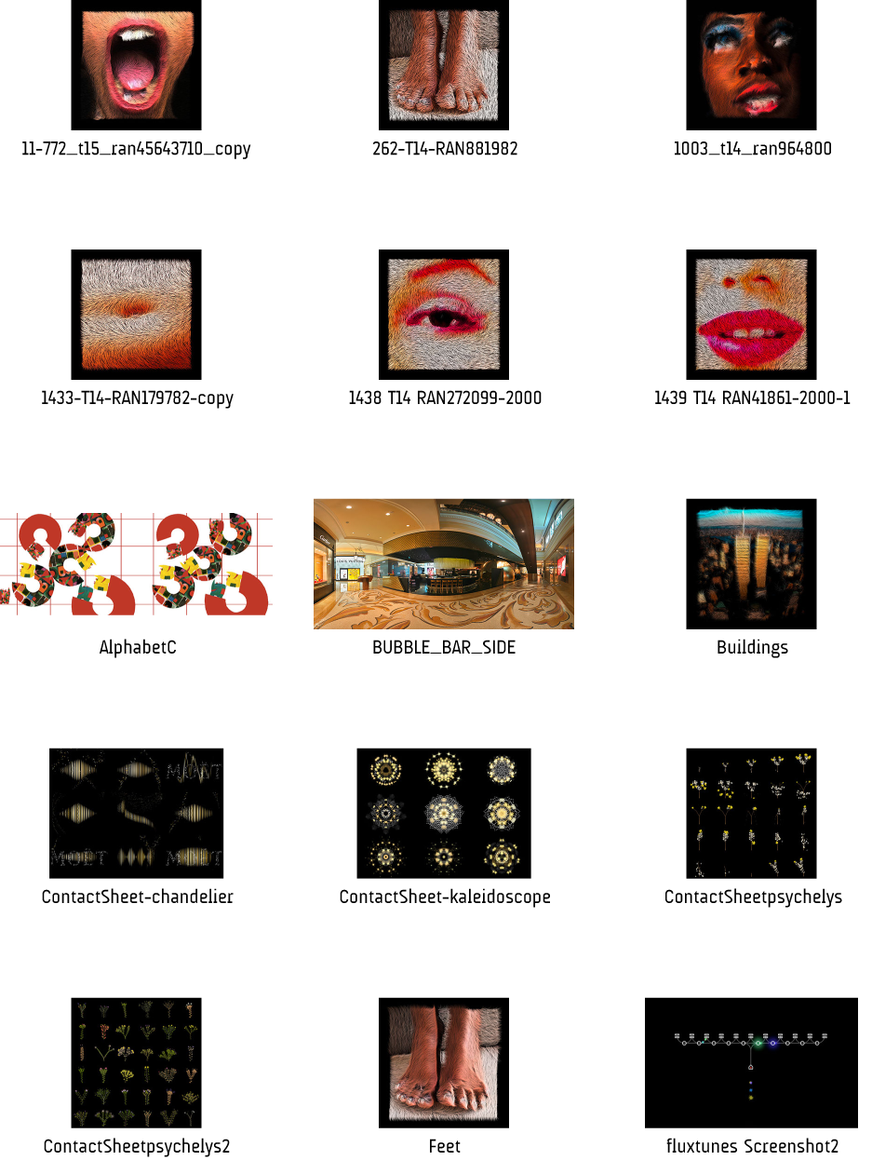

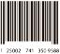
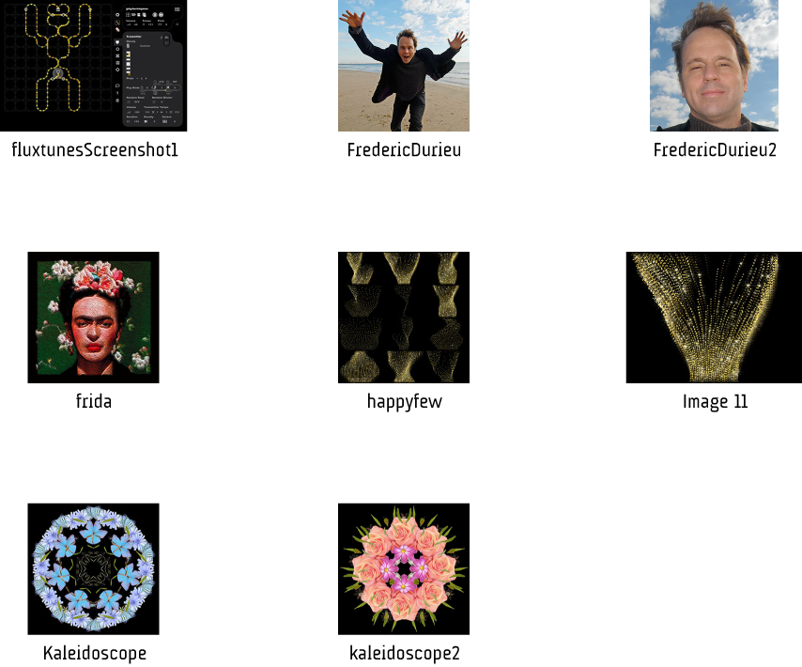
Barcode

